European  curriculum vitae  format   |  |  |  | 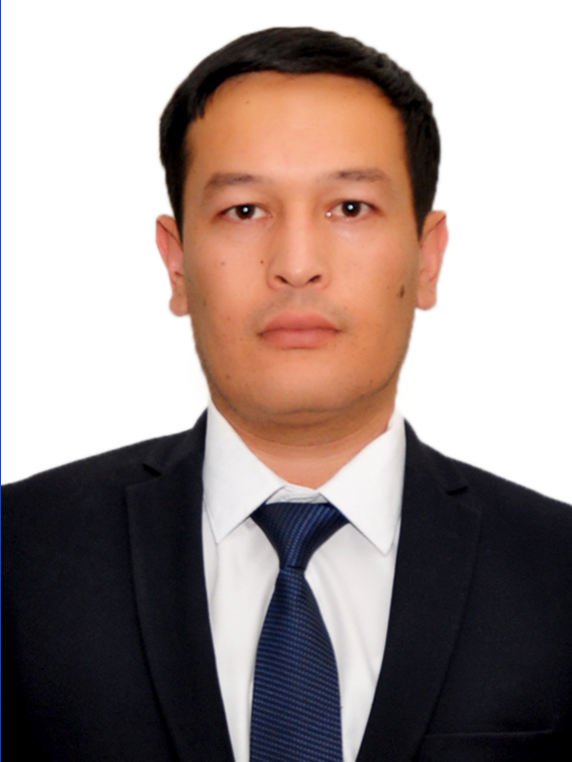
Personal information
Name |  | Mamatov Islom Isomiddinovich
Home Address |  | 32/11, Iftikhor str., Samarkand, Uzbekistan
Telephone |  | +99893 993-81-28
E-mail |  | islommamatov1988@gmail.com
Nationality |  | Uzbekistan
Date of birth |  | 03.11.1988
Passport |  | AA3465425, State personalization centre Samarkand region, Uzbekistan
Sphere of scientific interests |  | Software engineering, Network administration, Network security
Work experience
• Dates (September 2019 until now)
• Name and address of employer |  | Samarkand branch of Tashkent university of information technologies named after Muhammad al –Khwarizmi, Samarkand, 2 Ibn Sino str., 140100 Uzbekistan
• Type of business or sector |  | Information Technologies Center, Department of Information Security
• Occupation or position held |  | Head of Information Technologies Center, Assistant lecturer at Department of Information Security
• Main activities and responsibilities |  | Controlling University LAN; Analysis network traffics; Organizing IT Center activities; Activity in Information Security, teaching Cyber Security course
• Dates (May 2018 – September 2019)
• Name and address of employer |  | Samarkand branch of Tashkent university of information technologies named after Muhammad al –Khwarizmi, Samarkand, 2 Ibn Sino str., 140100 Uzbekistan
• Type of business or sector |  | Information Technologies Center
• Occupation or position held |  | Software engineer
• Main activities and responsibilities |  | Developing and managing University homepage
• Dates (September 2017- May 2018)
• Name and address of employer |  | Samarkand branch of Tashkent university of information technologies named after Muhammad al –Khwarizmi, Samarkand, 2 Ibn Sino str., 140100 Uzbekistan
• Type of business or sector |  | Department of Software engineering
• Occupation or position held |  | Assistant lecturer
• Main activities and responsibilities |  | Teaching C++ programming, project management courses
• Dates (September 2017- May 2018)
 |  | Samarkand branch of Tashkent university of information technologies named after Muhammad al –Khwarizmi, Samarkand, 2 Ibn Sino str., 140100 Uzbekistan
 |  | Department of Information security
 |  | Assistant lecturer
 |  | Activity in Information Security, teaching Cryptography, analysis network traffics
Education and training
• Dates (2009-2013)
• Name and type of organization providing education and training |  | Samarkand branch of Tashkent university of information technologies named after Muhammad al –Khwarizmi, Samarkand, Uzbekistan (Bachelors)
• Principal subjects/occupational  skills covered |  | Information Technologies
• Title of qualification awarded |  | Diploma № 676376
• Dates (2014-2016)
• Name and type of organization providing education and training |  | Samarkand branch of Tashkent university of information technologies named after Muhammad al –Khwarizmi, Samarkand, Uzbekistan ( (Master degree)
• Principal subjects/occupational  skills covered |  | Computer engineering
• Title of qualification awarded |  | Diploma № 086991
• Dates (January 2018)
• Name and type of organization providing education and training |  | University of Nicosia, Cyprus
• Principal subjects/occupational  skills covered |  | Distance Learning Essentials, Moodle Essentials, Creative Media Essentials
• Title of qualification awarded
Personal skills
and competences
Mother tongue |  | Uzbek
Other languages |  | Russian
• Reading skills |  | excellent
• Writing skills |  | good
• Verbal skills |  | good
Other languages |  | English
• Reading skills |  | excellent
• Writing skills |  | Good
• Verbal skills |  | good
Social skills  and competences |  | Excellent ability of communication and ability to attract attention
Organisational skills  and competences |  | Good capacity to coordinate and implement complicated projects proved by numerous responsibilities held
Technical skills  and competences  With computers, specific kinds of equipment, machinery, etc. |  | Excellent ability in navigate through the Internet  Excellent knowledge of Computer systems and networks  Excellent knowledge in network administration and network security, Server operation systems and Web technologies  Good knowledge in programming languages: C/C++, JavaScript, Typescript, Python, Java.
Artistic skills |  | -
Marital status |  | Married
Other relevant information (e.g., Publications, PROJECTS…) |  | PUBLICATIONS  His published work consisted of more 10 articles in sphere of software engineering. Below is presented some his publication works:
Other relevant information (e.g., Publications, PROJECTS…) |  | 1. | Khaldjigitov A.A, Mamatov I.I. Mobile guide application for travelers of Samarkand, infoCOM.uz, #5, Tashkent, 2016
Other relevant information (e.g., Publications, PROJECTS…) |  | 2. | Mamatov I.I., Lee J.J., Nasimov A. The role of information technologies for developing of tourism in Samarkand city, FOSS4G (Free and Open Source Software for Geospatial - Journal) 2015. Seoul, South Korea | September 14th – 19th , 2015
Other relevant information (e.g., Publications, PROJECTS…) |  | 3. | Mamatov I.I. “Offline guide of Samarkand. Samapp project. The first student’s scientific and practical conference “Intellectual generation of Uzbekistan”. - Tashkent, Uzbekistan April 10-11, 2015.
Other relevant information (e.g., Publications, PROJECTS…) |  | 4. | Mamatov I.I. Creating algorithm for software for help to finding touristic objects. TUIT SB Students Conference on Information Science and Communications Technologies. – Samarkand, Uzbekistan. May 2014.
Other relevant information (e.g., Publications, PROJECTS…) |  | 5. | Mamatov I.I. Creating foreign languages dictionary software for touristic objects. TUIT SB Students Conference on Information Science and Communications Technologies. – Samarkand, Uzbekistan. May 2014.
Other relevant information (e.g., Publications, PROJECTS…) |  | 6. | Mamatov I.I. The analysis of softwares for help to finding touristic objects TUIT SB Students Conference on Information Science and Communications Technologies. – Samarkand, Uzbekistan. May 2013.

